**Lesson07 Azure App Service with custom Domain.docx**

**Notes: -**

**1-as you can see below, when the user redirects this custom domain URL it will redirect to the azure app service**

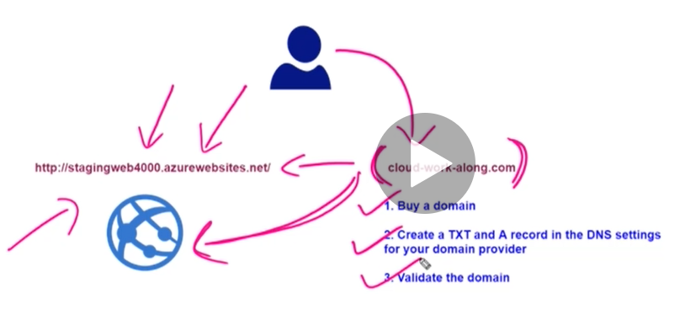

**Steps:-**

**1-on Azure app service we go to the custom domains and enter the GoDaddy domain name as below**

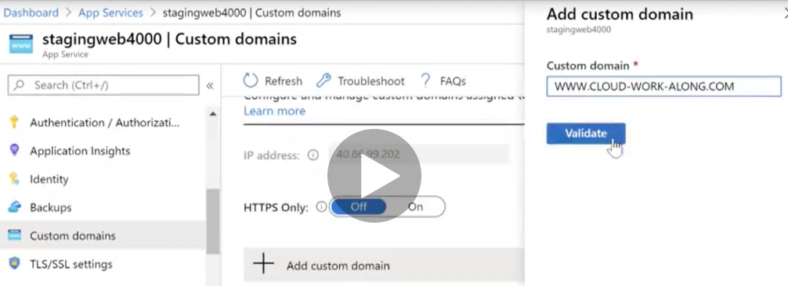

**2-it will produce TXT and CNAME that can be used on the GoDady custom domain as below**

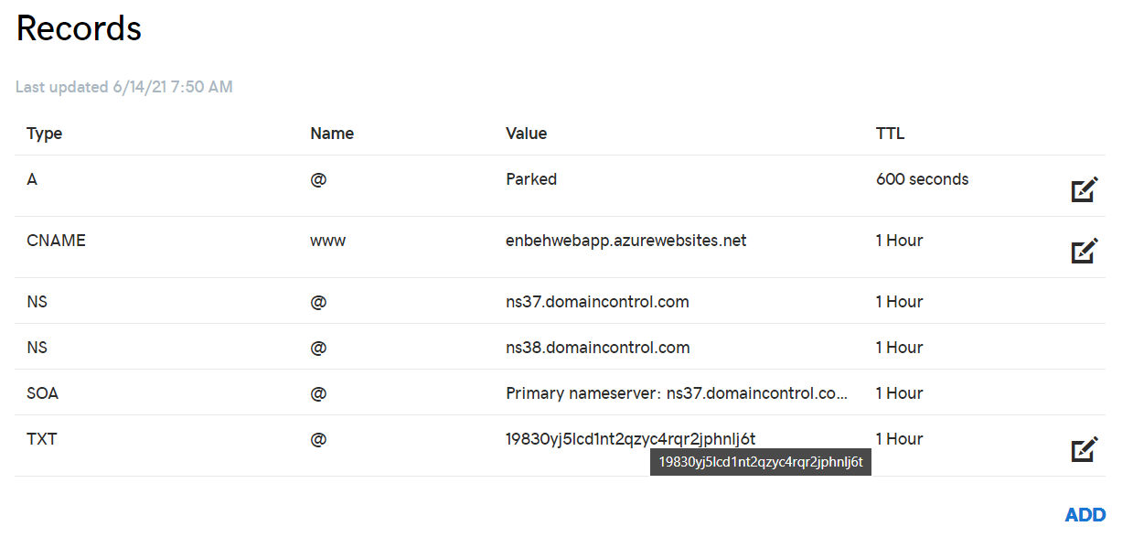

**3-wait couple of minutes and then click validate and once its validated click on the Add custom domain and you will see that the GoDaddy domain name it will show on the azure app service as below**

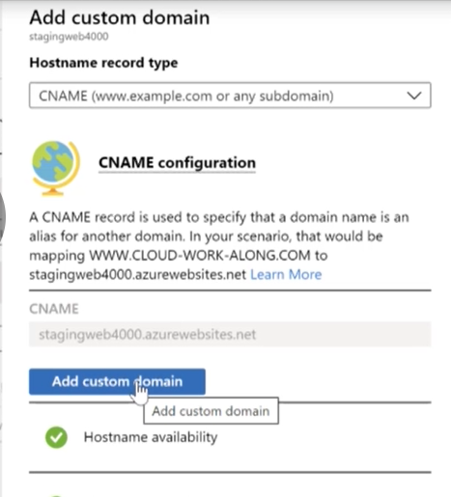

**7-we see that the app service enable http protocol**

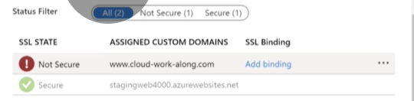

**(So, when navigate to the custom domain it will redirect to HTTP URL)**

**Azure APP service SSL**

**(to deploy SSL between Custom Domains and the Azure App service during SSL)**

**1-on app service > TLS/SSL seetings > select private Key certificates (by buy certificate or create app service managed certificate)**

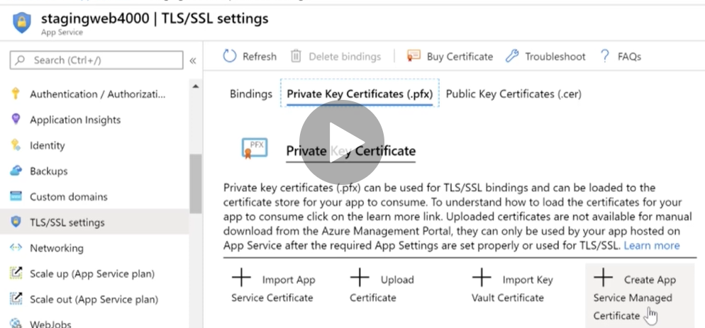

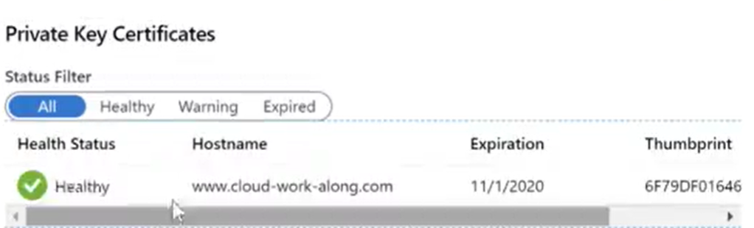

**2-on App Service > Custom Domains (we add binding certificate)**

